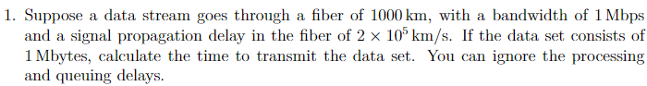

Propagation delay = Length of the fiber / Signal propagation speed

(1000km)/(2\*10^5 km/s) = 0.005 seconds = 5 milliseconds

Transmission time = Data set size/Bandwidth

Bandwidth = 1 Mbps = 1000000 bits per second

Data set size = 1 Mbyte = 1000000 bytes = 8000000 bits

8000000/1000000 = 8 seconds

Total time = transmission time + propagation delay

8+0.005 = 8.005



Propagation delay = 20 milliseconds = 0.02 seconds

Transmission time = Data set size/Bandwidth

2 kbytes = 2\* 1024 bytes = 2048 bytes = 16384 bits

10 mbps = 10000000 bits/s

16384 /10000000 = 0.0016384 seconds

Total time = 0.0016384 + 0.02 = 0.0216384 seconds

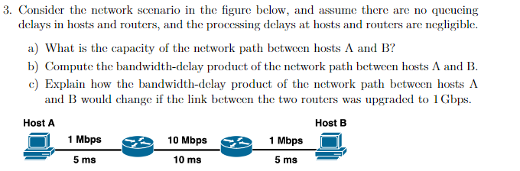

A The capacity of the network path is the link with the lowest bandwidth which is 1 mbps.

B Bandwidth delay = Bandwidth \* Delay = 1 mbps \* 20ms = 0.02 mbps = 20000 bits.

C It’s the same due to the link with the lowest bandwidth remains the same at 1 mbps.



It works by using cookies which is stores data on the client which is sent by the server usually a unique id the server can use to get a saved state.